Green River Kentucky Workforce Area

MEMORANDUM OF UNDERSTANDING (MOU)

July 1,2019 to June 30, 2022

Legal Authority

The Workforce Innovation and Opportunity Act (WIOA) sec. 121 (c)(1) requires the Local Board, with the agreement of the Chief Local Elected Official (CLEO) to develop and enter into a Memorandum of Understanding (MOU) between the Board and the One-Stop (Career Center) Partners, consistent with WIOA Sec 121 (c)(2), concerning the operation of the one-stop delivery system in local areas. This requirement is further described in the Workforce Innovation and Opportunity Act; Joint Rule for Unified and Combined State Plans, Performance Accountability, and the One-Stop System Joint Provisions: Final Rule at 20 CFR 678.500, 34 CFR 361.500, and 34 CFR 463.500, and in Federal Guidance.

Additionally, the sharing and allocation of infrastructure costs among one-stop partners is governed by WIOA sec. 121(h), its implementing regulations, and the Federal Cost Principles contained in the Uniform Administrative Requirements, Cost Principles, and Audit Requirements for Federal Awards (Uniform Guidance at 2 CFR part 200).

For Implementation of the Workforce Innovation and Opportunity Act (WIOA)

The following MOU (the Agreement) sets forth the terms of understanding for cooperation and consultation with regard to implementation of the WIOA among the following Agencies (the Agencies) within the Green River Kentucky Workforce System (the System).

The Agencies agree to work with the following partners who comprise the Workforce System in carrying out the requirements within the Agreement. This Agreement is between the Green River Workforce Development Board (WDB), with the concurrence of the Local Elected Officials (LEOs) of the Region serving on the Green River Governing Board, and the following Agencies (See Attachment A):

- WIOA Title I Programs
  - Adult (ResCare)
  - Dislocated Workers (ResCare)
  - Youth (ResCare)
  - Job Corps (Earle C. Clements Job Corps Academy)
  - Migrant and Seasonal Farmworkers
- WIOA Title III Wagner-Peyser (Career Development Office)
- Kentucky Office of Adult Education Skills U
- Vocational Rehabilitation
- Senior Community Service Employment Program (Audubon Area Community Services, Evansville Goodwill Industries, Goodwill Industries of Kentucky)
- Carl D. Perkins Career and Technical Education (Owensboro Community and Technical College, Henderson Community College)
- Trade Adjustment Assistance (Career Development Office, ResCare)
- Job for Veterans (Career Development Office)
- Community Services Block Grant (Audubon Area Community Services)
- Department of Housing and Urban Development (Owensboro Housing Authority)
- Unemployment Insurance (Office of Unemployment Insurance)
- TANF (Audubon Area Community Services)
- Office of Employer and Apprenticeship Services

- Strategic Vision for the System
It is the vision of the WDB to produce a skilled workforce to obtain quality jobs and meet the needs of local employers. Goals include:
- Provide occupational skills training to individuals needed to fill current and emerging high wage, high-demand jobs.
- Ensure that employers have the skilled workforce needed to remain competitive and to contribute to the local and statewide economic growth.
- Ensure that the workforce system is aligned, provides integrated services and makes valuable and productive use of resources to attain prominent, successful outcomes for all customers, including job seekers and employers.
- Ensure services are provided and there is continued partnership with educational programs to ensure that essential skill requirements are met and job seekers are ready to begin work and retain jobs. It is imperative that workers have skills needed that allow them to be competitive for high-wage, high-demand jobs. Investments must be made that assure workforce needs of business and industry are supported.
- Work with partners in the workforce system to identify skills gaps in order to determine which strategies to create, expand, or eliminate.
- Operate under a common vision addressing the opportunities identified in the Agreement and use statewide strategies and measurable outcomes to efficiently operate workforce programs.

The WDB strives to align its’ work with that of the Commonwealth of Kentucky’s goals, initiatives and priorities. This is reflected through many efforts as listed:

- Sector Strategies – training is provided only in sectors that contain high demand/high growth occupations within the local area. The WDB establishes those sectors.
- Work Ready Communities – the Green River Workforce Development Area (WDA) was the first area in the state to have all seven counties certified as Work Ready Communities or Work Ready in Progress Communities.
- Career Center Certification – the WDB has certified one comprehensive center and two affiliate centers to date.
- Business Services Team (BST) – the BST is established with representatives from all partners, concentrating on employer needs.
- User-friendly online services – Focus Career and Focus Talent are operational.
- National Career Readiness Certificate (NCRC) – Adult Education Learning Centers offer the WorkKeys assessment that leads to the NCRC.
- Statewide Eligible Training Provider List (ETPL) – the ETPL list is operational and managed by the Career Development Office (CDO)
- Kentucky Career Center (KCC) Concept – partners are co-located to offer seamless services to both jobseeker and employer customers.

- Mission
The Green River Workforce Development Board serves as a liaison between employers in the business, industry, and public sector and individuals in order to make workforce needs known. The WDB also promotes and provides tactics to motivate individuals to continue their education and improve their work skills. It is also our intent to encourage and assist in the development of new training programs to benefit the region’s workforce. The WDB conducts planning, oversight, and analysis of local workforce development programs through the local Career Centers. We strive to promote the region’s availability of qualified workers by matching efforts and activities with economic development goals.

The mission of the Green River Workforce Development Board is to provide an integrated system of quality employment information and training services to businesses and individuals through staffing and technology utilizing accessible KCC service sites.

- System Structure
American Job Centers—Kentucky Career Center

The WDA has one comprehensive Kentucky Career Center, designed to provide a full range of assistance to job seekers and businesses under one roof. Established under the Workforce Investment Act of 1998 and continued by the WIOA, the Kentucky Career Center offers a comprehensive array of services designed to match talent with opportunities.

KCC--Owensboro
3108 Fairview Drive
Owensboro, KY 42301
270.687.7297
Hours: Monday – Friday – 8:00 am to 4:30 pm

- Agency On-Site Representation Schedule

KCC Owensboro
Agency | # of Staff | Weekly Staff Hours | # FTEs | % of Total FTEs
Career Development Office (CDO) | 5 | 187.5 | 5 | 21
Office of Vocational Rehabilitation (OVR) | 14 | 525 | 14 | 58
ResCare | 5 | 200 | 5 | 21

- Purpose of Agreement
It is the purpose of this Agreement to establish a cooperative and mutually beneficial relationship among the Agencies and to set forth the relative responsibilities of the Agencies insofar as they relate to planning and implementation of individual and mutual duties, obligations, and responsibilities under the WIOA.

- General Provisions
It is understood by the Agencies that each should be able to fulfill its responsibilities under the Agreement in accordance with the provisions of law and regulations which govern their activities. Nothing in the Agreement is intended to negate or otherwise render ineffective any such provisions or operating procedures.

To ensure the utmost flexibility for all Agencies within the Agreement, it is understood and agreed that two or more Agencies may enter into separate Supplemental Agreements among themselves. Such Supplemental Agreements, when relevant to the WIOA, may become part of the Agreement as long as they are consistent with the terms of the Agreement and do not impose any duties or obligations on any other party to the Agreement without such party’s express written consent. The Supplemental Agreements shall specify what the individual agreements are and the obligations that are applicable to the two or more Agencies involved in such Supplemental Agreements. These Supplemental Agreements shall also be subject to all the terms in the Agreement.

- Duration of Agreement
The Agreement will commence on the 7/1/2019 and shall remain in full force for a maximum of three years through the 6/30/2022. The Agreement may be canceled by the Agencies in accordance with the terms set forth herein. The Agreement supersedes previous agreements.

8. Responsibilities of the Agencies Under the Agreement
In consideration of the mutual aims and desires of the Agencies participating in the Agreement and in recognition of the public benefit to be derived from effective partnerships, the Agencies agree that their respective responsibilities under The Agreement shall be as follows:

8.1 All Parties
All Parties to the Agreement shall comply with:
- Section 188 of the WIOA Nondiscrimination and Equal Opportunity Regulations (29 CFR Part 38; Final Rule, published December 2, 2016),
- Title VI of the Civil Rights Act of 1964 (Public Law 88-352),
- Section 504 of the Rehabilitation Act of 1973, as amended,
- The Americans with Disabilities Act of 1990 (Public Law 101-336),
- The Jobs for Veterans Act (Public Law 107-288) pertaining to priority of service in programs funded by the US Department of Labor,
- Training and Employment Guidance letter (TEGL 37-14), Update on Complying with Nondiscrimination Requirements: Discrimination Based on Gender Identity, Gender Expression and Sex Stereotyping are Prohibited Forms of Sex Discrimination in the Workforce Development System and other guidance related to implementing WIOA sec. 188,
- The Family Educational Rights and Privacy Act (FERPA) (20 U.S.C. §1232g; 34 CFR part 99),
- Confidentiality requirements governing the protection and use of personal information held by the OVR (34 CFR part 603),
- UI should be added here
- All amendments to each, and
- All requirements imposed by the regulations issued pursuant to these acts.
The above provisions require, in part, that no persons in the United States (U.S.) shall, on the grounds of race, color, national origin, sex, sexual orientation, gender identity and/or expression, age, disability, political beliefs or religion be excluded from participation in, or denied, any aid, care, services or other benefits provided by Federal and/or State funding, or otherwise be subjected to discrimination.

Additionally, all Parties shall:
- Collaborate and reasonably assist each other in the development of necessary service delivery protocols for the services outlined in section 8.6 “The Agencies” section.
- Agree that the provisions contained herein are made subject to all applicable Federal and State laws, implementing regulations, policies, and guidelines imposed on either or all the Agencies relating to the privacy rights of customers, maintenance of records, and other confidential information relating to customers, and
- Agree that all equipment and furniture purchased by any Agency for purposes described herein is and shall remain the property of the purchaser after the termination of this agreement.
8.2 The Green River Governing Board
The CLEO for the WDA is the Daviess County Judge Executive. The CLEO will, at a minimum:
- In partnership with the WDB and other applicable partners within the planning region, develop and submit a single regional plan that includes a description of the activities that shall be undertaken by all local workforce boards and their partners, and that incorporates plans for each of the WDAs in the planning region.
- Approve the WDA budget and workforce center cost allocation plan.
- Approve the selection of the One-Stop Operator (OSO) following the competitive procurement process, and
- Coordinate with the WDB to oversee the operations of the WDA KCC network.
8.3 Green River Workforce Development Board
The WDB ensures the workforce-related needs of employers and job seekers in the WDA, to the maximum extent possible with available resources. The WDB will, at a minimum:
- In partnership with the CLEO and other applicable partners within the WDA, develop and submit a local area plan that includes a description of the activities that shall be undertaken by the WDA and its partners, and that aligns its strategic vision, goals, objectives, and workforce-related policies to the state plan, regional plan and economy.
- In partnership with the CLEO and other applicable partners within the planning region, develop and submit a single regional plan that includes a description of the activities that shall be undertaken by all WDBs and their partners, and that incorporates plans for each of the WDAs in the planning region,
- In collaboration and partnership with the CLEO and other applicable partners within the planning region, develop the strategic vision, goals, objectives and workforce-related policies,
- In cooperation with the CLEO and the other WDBs within the regional area, design and approve the KCC network structure. This includes, but is not limited to:
  - Adequate, sufficient, and accessible one-stop center locations and facilities,
  - Sufficient numbers and types of providers of career and training services (including eligible providers with expertise in assisting individuals with disabilities and eligible providers with expertise in assisting adults in need of adult education and literacy activities),
  - A holistic system of supporting services, and
  - One or more competitively procured OSOs.
- In collaboration with the CLEO, designate through a competitive process, oversee, monitor, implement corrective action, and if applicable, terminate the OSO.
- Determine the role and day-to-day duties of the OSO,
- Leverage additional funding for the KCC network to operate and expand one-stop customer activities and resources, and
- Review and evaluate the WDA and OSO.
8.4 Green River Workforce Development Board Staff
Specific responsibilities include, at a minimum:
- Assist the CLEO and the WDB with the development and submission of a local plan and single regional plan,
- Support the WDB with the implementation and execution of the WDA vision, goals, objectives, and workforce-related policies, including all duties outlined above,
- Provide operational and grant-specific guidance to the OSO,
- Investigate and resolve elevated customer complaints and grievance issues,
- Prepare regular reports and recommendations to the WDB, and
- Oversee negotiations and maintenance of MOUs with the one-stop partners.
8.5 One Stop Operator
Specific responsibilities include, at a minimum:
- Provide seamless services between KCC programs including but not limited to, Adult, Dislocated Worker, Youth, Business Services, Wagner-Peyser, Trade Act, Veterans Programs, TANF, Supplemental Nutrition Assistance Program (SNAP), Adult Education, Vocational Rehabilitation.
- Implement an integrated service delivery model that embraces the Team-Based Case Management (TBCM) approach. The mission of TBCM is to offer coordinated workforce development and direct customer service to employers and job seekers at one accessible location. Work with all Agencies and the WDB to ensure that each is familiar with the general services that each of the Agencies provides to job seekers. Work with the Agencies and encourage collaboration to seek to work with other partners outside of the KCC.
- Identify the Agencies key functions, activities, goals, outcomes and contributions to benefit the KCC and the entire System.
- Ensure that basic services such as orientations, labor market information dissemination and resource rooms are available.
- Collaborate with the Agencies to develop, maintain, update and implement the required MOU and Infrastructure Funding Agreement (IFA), along with WDB and its staff, so that the Agencies actively participate in the development and negotiation process. Provide leadership and coordination for the integration of partner services into the KCC system.
- Improve customer access to the Agencies services through implementation of a common intake, common application, and common case management and referral processes as required under WIOA or any other workforce programs administered by the WDB and/or through the KCC. Strive to streamline services and minimize duplication.
- Establish a regular and continuous method of communication with the Agencies and front-line staff.
- Leverage additional funding streams including those that support training, as well as in-kind and monetary contributions from regional organizations and businesses.
- Collaborate with other pertinent organizations in the community to meet the needs of customers.
- Collaborate with the WDB to implement System initiatives and specific grant activities for which the WBD and the System participation has been required.
- Collaborate with the state, WDB and the Agencies as necessary to implement state-generated initiatives related to KCC services.
- Complete, assist, implement and oversee the KCC certification process in any/all comprehensive career centers and affiliate career centers.
- Assist in the implementation of the WDB policies and goals and to adhere to all Federal and State laws and all Federal, State and Local policies.
- Foster a culture of collaboration and excellent customer services among the Agencies and promote high quality innovative services.
- Create and implement a survey to determine Customer (Job Seeker and Employer) Satisfaction of the KCC, which includes the Agencies located in the KCC.
- Ensure cross-training and development plans are established for the staff of the Agencies within the KCC. Determine the training needs of all the Agencies and secure the appropriate persons/entities to provide such training.
- Convene and lead regularly scheduled meetings (at least quarterly) of the Agencies that facilitate integrated partnerships that incorporate a seamless service for common customers and ensure that the System staff are well-trained, equipped and operating in a continuous learning environment with the skills and knowledge needed to provide superior services and evaluate processes through shared goals. Keep and maintain meeting minutes for all meetings.
- Manage daily operations of physical structure, utilities and staff work space to provide an acceptable working environment.
- Maintain a Standard Operating Procedures manual. Provide and maintain safety and security plans and organize appropriate safety drills.
- Provide support, assistance and resolution to all staff in response to collaboration issues, facility needs, safety considerations and other issues or concerns. Assure basic services are available and operable: technology, resource room equipment, phones etc.
- Assist in the resolution of any/all customer complaints, problems and other issues at the KCC. Provide information/direction to any customer seeking to file a formal complaint against any of the Agencies.
- Manage the hours of operation based on job-seeker and employer needs.
- Work collaboratively with the Agencies to continuously measure, analyze and improve metrics that define a high performing system. Ensure all feedback from job seekers, business, community partners, mandated partners, and the WDB is integrated to inform and improve the workforce system. Work with the Agencies to evaluate customer flow.
- Work with the Agencies in cases of future changes and growth.
8.6 The Agencies
At a minimum, all KCC Agencies will make the required One Stop Services (below) available, as applicable to the program, consistent with and coordinated to meet the requirements of the WIOA; Final Rule, and in Federal guidance TEGL 16-16, State policies, guidance and the State Plan as a part of the American Job Center network system. The Agencies will collaborate to ensure that all KCC’s in the WDA are high-performing work places with staff who will ensure quality of service. The Agencies agree to promote, provide, refer and/or link customers to the following career services as defined by WIOA; additional services may be provided on a case-by-case basis at the KCC and with the approval of the WDB and the CLEO.

8.6.1 Business Services
- Foster and enhance relationships with businesses.
- Assess needs of local businesses.
- Conduct outreach regarding local workforce system’s services and products.
- Conduct on-site Rapid Response activities regarding closures and downsizings.
- Provide access to labor market information.
- Provide customized recruitment and job applicant screening, assessment and referral services.
- Assist with the interpretation of labor market information.
- Conduct Job Fairs.
- Develop customized training opportunities to meet specific employer and/or industry-cluster needs.
- Use of one-stop center facilities for recruiting and interviewing job applicants.
- Consult on human resources issues.
- Coordinate with employers to develop and implement layoff aversion strategies.
- Provide information regarding disability awareness issues.
- Provide information regarding workforce development initiatives and programs.
- Provide information regarding assistive technology and communication accommodations, including job coaches.
- Develop, convene, or implement industry or sector partnerships.
- Accommodate or refer to as appropriate registered apprenticeship services

8.6.2 Job Seeker Services-Basic Career Services
- Outreach, intake and orientation to the information, services, programs, tools and resources available through the System.
- Initial assessments of skill level(s), aptitudes, abilities and supportive service needs.
- Access to employment opportunity and labor market information.
- Performance information and program costs for eligible providers of training, education, and workforce services.
- Information on performance of the local workforce system.
- Information on the availability of supportive services and referral to such, as appropriate.
- Information and meaningful assistance on UI claim filing.
- Determination of potential eligibility for the Agencies services, programs, and referral(s).
- Information and assistance in applying for financial aid for training and education programs not provided under WIOA.

8.6.3 Job Seeker Services-Individualized Career Services
- Comprehensive and specialized assessments of skills levels and service needs.
- Development of an individual employment plan to identify employment goals, appropriate achievement objectives, and appropriate combinations of services for the customer to achieve the employment goals.
- Referral to training services.
- Group counseling.
- Literacy activities related to work readiness.
- Individual counseling and career planning.
- Case management for customers seeking training services.
- Individual In and Out of Area Job Search, referral and placement assistance.
- Work experience, transitional jobs, registered apprenticeships, and internships.
- Workforce preparation services (e.g., development of learning skills, punctuality, communication skills, interviewing skills, personal maintenance, literacy skills, financial literacy skills, and professional conduct) to prepare individuals for unsubsidized employment or training.
- Adult education and literacy activities, including English language acquisition (ELA), provided in combination with the training services.

8.6.4 Training
- Occupational skills training through Individual Training Accounts (ITAs).
- On-the-Job Training (OJT).
- Incumbent Worker Training and skill upgrading and retraining.
- Programs that combine workplace training with related instruction which may include cooperative education.
- Training programs operated by the private sector.
- Entrepreneurial training.
- Customized training conducted with a commitment by an employer or group of employers to employ an individual upon successful completion of the training.
- Other training services as determined by the Agencies governing rules.

8.6.5 Youth Services
- Tutoring, study skills training, instruction, and evidence-based dropout prevention and recovery strategies that lead to completion of the requirements for a secondary school diploma or its recognized equivalent (including a recognized certificate of attendance or similar document for individuals with disabilities) or for a recognized postsecondary credential.
- Alternative secondary school services, or dropout recovery services, as appropriate.
- Paid and unpaid work experiences that have as a component academic and occupational education, which may include:
  - Summer employment opportunities and other employment opportunities available throughout the school year
  - Pre-apprenticeship programs
  - Internships and job shadowing
  - On-the-job training opportunities.
- Occupational skill training, which shall include priority consideration for training programs that lead to recognized postsecondary credentials that are aligned with in-demand industry sectors or occupations in the local area involved.
- Education offered concurrently with, and in the same context as, workforce preparation activities and training for a specific occupation or occupational cluster.
- Leadership development opportunities, which may include community service and peer-centered activities encouraging responsibility and other positive social and civic behaviors, as appropriate.
- Supportive services.
- Adult mentoring for the period of participation and a subsequent period, for a total of not less than 12 months.
- Follow-up services for not less than 12 months after the completion of participation, as appropriate.
- Comprehensive guidance and counseling, which may include drug and alcohol abuse counseling and referral, as appropriate.
- Financial literacy education.
- Entrepreneurial skills training.
- Services that provide labor market and employment information about in-demand industry sectors or occupations available in the local area, such as career awareness, career counseling, and career exploration services.
- Activities that help youth prepare for and transition to postsecondary education and training.

8.7 System Wide Commitments
The Agencies commit to cross-educate staff, as appropriate, and to providing other professional learning opportunities that promote continuous quality improvement. Each agency shall be committed to providing and/or linking customers to additional services as described in Appendix B. The Agencies will further promote system integration to the maximum extent feasible through:
- Effective communication, information sharing, and collaboration with the OSO,
- Joint planning, policy development and system design processes,
- Commitment to the joint mission, vision, goals, strategies and performance measures,
- The use of common and/or linked data management systems and data sharing methods, as appropriate, and
- Leveraging of resources, including other public agency and non-profit organization services.

- Data Sharing
The Agencies agree that the use of high-quality, integrated data is essential to inform decisions made by policymakers, employers, and job seekers. Additionally, it is vital to develop and maintain an integrated case management system, as appropriate, that informs customer service throughout customers’ interaction with the integrated system and information to be captured and collected from customers at intake.

The Agencies further agree that the collection, use and disclosure of customers’ personally identifiable information (PII) is subject to various requirements set forth in Federal and State privacy laws. The Agencies acknowledge that the execution of the Agreement, by itself, does not function to satisfy all of these requirements.

All data, including customer PII, collected, used, and disclosed by Partners will be subject to the following:
- Customer PII will be properly secured in accordance with the federal and state guidance as well as state KCC policies and procedures (located on the KCC Team of Experts site) regarding the safeguarding of PII.
- The collection, use, and disclosure of customer education records, and the PII contained therein, as defined under FERPA, shall comply with FERPA and applicable State privacy laws.
- All confidential data contained in UI wage records must be protected in accordance with the requirements set forth in 20 CFR part 603 and KRS 341.190.
- All personal information contained in VR records must be protected in accordance with the requirements set forth in 34 CFR 361.38.
- All personal information contained in WIOA Title I records must be protected in accordance with the requirements set forth in TEGL 39-11.
- Customer data may be shared with other programs, for those programs’ purposes, within the American Job Center network only after the informed written consent of the individual has been obtained, where required.
- Customer data will be kept confidential, consistent with Federal and State privacy laws and regulations.
- All data exchange activity will be conducted in machine readable format, such as HTML or PDF, for example, and in compliance with Section 508 of the Rehabilitation Act of 1973, as amended (29 U.S.C. § 794 (d)).

All of the Agencies staff will be trained in the protection, use and disclosure requirements governing PII and any other confidential data for all applicable programs, including FERPA-protected educational records, confidential information in UI records, and personal information in OVR records.

- Confidentiality
The Agencies expressly agree to abide by all applicable Federal, State and Local laws and regulations regarding confidential information, including PII from educational records, such as but not limited to 20 CFR Part 603, 45 CFR Section 205.50, 20 U.S.C. 1232g and 34 CFR part 99, and 34 CFR 361.38, as well as any applicable State and local laws and regulations. In addition, in carrying out their respective responsibilities, the Agencies shall respect and abide by the confidentiality policies and legal requirements of all of the Agencies.

The Agencies will ensure that the collection and use of any information, systems, or records that contain PII or other personal or confidential information will be limited to authorized staff members who are assigned responsibilities in support of the services and activities described herein and will comply with applicable law. The Agencies expressly agree to take measures to ensure that no PII or other personal or confidential information is accessible by unauthorized individuals.

To the extent that confidential, private, or otherwise protected information needs to be shared amongst the Agencies for the Agencies’ performance of their obligations under this MOU, and to the extent that such sharing is permitted by applicable law, the appropriate data sharing agreements will be created and required confidentiality and ethical certifications will be signed by authorized individuals. With respect to confidential UI information, any such data sharing must comply with all the requirements in 20 CFR Part 603 and KRS 341.190, including but not limited to requirements for an agreement consistent with 20 CFR 603.10, payment of costs, and permissible disclosures.

With respect to the use and disclosure of FERPA-protected customer education records and the PII contained therein, any such data sharing agreement must comply with all the requirements set forth in 20 U.S.C. §1232g and 34 CFR Part 99.

With respect to the use and disclosure of PII contained in OVR records, any such data sharing agreement must comply with all the requirements set forth in 34 CFR 361.38.

- Referrals
The primary principle of the referral system is to provide integrated and seamless delivery of services to job seekers and employers. In order to facilitate such a system, the Agencies agree to move to:
- Familiarize themselves with the basic eligibility and participation requirements, as well as with the available services and benefits offered, for each of the Agencies programs represented in the KCC network,
- Develop materials summarizing respective program requirements and making them available for partners and customers,
- Develop and utilize common intake, eligibility determination, assessment and registration forms, as appropriate.
- Provide substantive referrals to customers who are eligible for supplemental and complementary services and benefits under the Agencies programs,
- Regularly evaluate ways to improve the referral process, including the use of customer satisfaction surveys,
- Commit to robust and ongoing communication required for an effective referral process, and
- Commit to actively follow up on the results of referrals and assuring the Agencies resources are being leveraged at an optimal level.

- Accessibility
Accessibility to the services provided by the KCC and the Agencies is essential to meeting the requirements and goals of the KCC network. Job seekers and employers must be able to access all information relevant to them via visits to physical locations as well as in virtual spaces, regardless of gender, age, race, religion, national origin, disability, veteran’s status, or on the basis of any other classification protected under State or Federal law.

  - Physical Accessibility
One-stop centers will maintain a culture of inclusiveness and the physical characteristics of the facility, both indoor and outdoor, will meet the latest standards of accessible design. Services will be available in a convenient, high traffic, and accessible location, taking into account reasonable distance from public transportation and adequate parking (including parking clearly marked for individuals with disabilities). Indoor space will utilize a Universal Design that provides access for individuals with disabilities.

  - Virtual Accessibility
The WDB will work with the Office of the Kentucky Workforce Innovation Board (OKWIB) to ensure that job seekers and employers have access to the same information online as in a physical facility. Information must be clearly marked and compliant with Section 508 of the U.S. Department of Health and Human Services code. The Agencies will comply with the Plain Writing Act of 2010; the law that requires that Federal agencies use "clear Government communication that the public can understand and use" and all information kept virtually will be updated regularly to ensure dissemination of correct information. The Agencies should have their own web presence via a website and/or the use of social media.

  - Communication Accessibility
Communications access, for purposes of the Agreement, means that individuals with sensory disabilities can communicate (and be communicated with) on an equal footing with those who do not have such disabilities. The Agencies agree that they will provide accommodations for individuals who have communication challenges, including but not limited to individuals who are deaf and hard of hearing, individuals with vision impairments, and individuals with speech-language impairments.

  - Programmatic Accessibility
The Agencies agree that they will not discriminate in their employment practices or services on the basis of gender, gender identity and/or expression, age, race, religion, national origin, disability, veteran’s status, or on the basis of any other classification protected under State or Federal law.
- The Agencies must assure that they have policies and procedures in place to address these issues, and that such policies and procedures have been disseminated to their employees and otherwise posted as required by law.
- The Agencies further assure that they are currently in compliance with all applicable State and Federal laws and regulations regarding these issues.
- The Agencies will cooperate with KCC compliance monitoring that is conducted by WDB staff to ensure that the Agencies programs, services, technology, and materials are physically and programmatically accessible and available to all.
- Additionally, staff members currently designated as EEO Coordinators, will be trained by the OSO and Center management in all programmatic elements offered by the Kentucky Career Center so as to provide KCC services to all, regardless of range of abilities, mobility, age, language, learning style, or comprehension or education level.
- An interpreter will be provided in real time or, if not available, within a reasonable timeframe to any customer with a language barrier.
- Assistive devices, such as screen-reading software programs (e.g., JAWS and DRAGON) and assistive listening devices must be available at the KCC to ensure physical and programmatic accessibility.

- Outreach
The OSO, with inclusion of the Agencies input, will develop and implement a strategic outreach plan to submit to the WDB that will include, at a minimum:
- Utilizing methods for outreach and marketing including, but not limited to, distributing printed material, being active on social media platforms and radio advertisements and attend various community events to provide information regarding the KCC,
- An outreach and recruitment plan to the region’s job seekers, including targeted efforts to populations most at-risk or most in need,
- Utilizing LMI, along with knowledge from the Business Services Team as the foundation for marketing,
- Developing an outreach and recruitment plan to meet the needs of the WDA and the customers it serves including, but not limited to, Adults, Dislocated Workers and Youth, based on knowledge of local employer needs, job seeker needs and other economic indicators.
- Clear objectives and outcomes, and
- Leveraging any statewide outreach materials relevant to the region.

- Monitoring
The WDB, or its designated staff, the Department of Workforce Investment (DWI), the U.S. Departments of Labor, Education and Health and Human Services have authority to conduct fiscal and programmatic monitoring to ensure that:
- Federal awards are used for authorized purposes in compliance with law, regulations, state policies, and WDB policies,
- Those laws, regulations, and policies are enforced properly,
- Performance data are recorded, tracked and reviewed for quality to ensure accuracy and completeness,
- Outcomes are assessed and analyzed periodically to ensure that performance goals are met,
- Appropriate procedures and internal controls are maintained, and record retention policies are followed, and
- The Agreement terms and conditions are fulfilled.

- Indemnification/Liability Clause
All parties to this MOU recognize the partnership consists of various levels of government, not-for-profit, and for-profit entities. Each party to this agreement shall be responsible for injury to persons or damage to property resulting from negligence on the part of itself, its employees, its agents, or its officers. Provided, however, in the event the party is a state agency or subcontracts for services with a state agency subject to the jurisdiction of the Kentucky Claims Commission pursuant to KRS 49.040 through KRS 49.170, the state agency’s tort liability shall be limited to an award from the Kentucky Claims Commission up to the jurisdictional amount. No partner assumes any responsibility for any other party, state or non-state, for the consequences of any act or omission of any third party. The parties acknowledge the Green River Workforce Development Board and the One-Stop Operator have no responsibility and/or liability for any actions of the one-stop center employees, agents, and/or assignees. Likewise, the parties have no responsibility and/or liability for any actions of the Green River Workforce Development Board or the One-Stop Operator.

- Severability
If any part of the Agreement is found to be null or void or is otherwise stricken, the rest of the Agreement shall remain in force.

- Priority of Services
Those Agencies, as outlined in 38 U.S.C. sec. 4215 and its implementing regulations and guidance, and WIOA sec. 134(c)(3)(E), certify that they will adhere to all US DOL and state statutes, regulations, policies, guidance and plans regarding priority of service in the KCC including, but not limited to, priority of service for veterans and their eligible spouses, and priority of service for the WIOA title I Adult program. KCC Partners will target recruitment of special populations that receive a focus for KCC services under WIOA, such as individuals with disabilities, low-income individuals, basic skills deficient youth, and English language learners, if WIOA services are provided.

- Drug and Alcohol-free Workplace
The Agencies party to the Agreement certify compliance with the Drug-Free Workplace Act of 1988, 41 U.S.C. 702 et seq., and 2 CFR part 182 which require that all organizations receiving grants from any Federal agency maintain a drug-free workplace. The Agencies must notify the awarding office if an employee of the Agencies is convicted of violating a criminal drug statute. Failure to comply with these requirements may be cause for suspension or debarment under 2 CFR part 180, as adopted by the U.S. Department of Education at 2 CFR 3485, and the USDOL regulations at 29 CFR part 94.

- Certification Regarding Lobbying
The Agencies shall comply with the Byrd Anti-Lobbying Amendment (31 U.S.C. Section1352), 29 C.F.R. Part 93, and 34 CFR part 82, as well as the requirements in the Uniform Guidance at 2 CFR 200.450. The Agencies shall not lobby Federal entities using Federal funds and will disclose lobbying activities as required by law and regulations.

- Debarment and Suspension
The Agencies shall comply with the debarment and suspension requirements (E.0.12549 and12689) and 2 CFR part 180 and as adopted by the USDOL at 29 CFR part 2998 and by the U.S. Department of Education at 2 CFR 3485.

- Governing Law
The Agreement will be construed, interpreted, and enforced according to the laws of the Commonwealth of Kentucky. The Agencies shall comply with all applicable Federal and State laws and regulations, and local laws to the extent that they are not in conflict with State or Federal requirements.

22. Amendment or Cancellation of Agreement
The Agreement may be amended at any time in writing and by mutual consent of the WDB, LEOs and the Agencies. Each Agency may cancel its participation in the Agreement upon sixty (30) days written notice to the other Agencies. In the event an Agency determines that funds are unavailable to carry out the activities set forth in this Agreement, the Agency shall terminate this Agreement by notifying all other Agencies in writing immediately and the Agreement shall terminate upon the delivery of such written notification. When the cancellation is for cause, i.e., a material and significant breach of any of the provisions of this Agreement, it may be canceled immediately upon delivery of written notice to the other Agencies.

23. Steps to Reach Consensus
23.1 Notification of Partners
The Green River Workforce Development Board (or designee) notified all Parties in April, 2018 that it was necessary to renew and execute the MOU and provide all applicable policies and preceding MOU documents, as applicable.

23.2 Kickoff Meeting
The Green River Workforce Development Board (or designee) is responsible for convening all required and optional American Job Center Partners to formally kick-off negotiations, and to ensure that, at a minimum, all American Job Center Partners from all centers within the Local WDA are appropriately represented. The kickoff meeting took place in May 2018 at the Kentucky Career Center in Owensboro, which was no later than within four (4) weeks of notification as it must be hosted in a timely manner to allow for all steps to be conducted in good faith and in an open and transparent environment.

At the kickoff meeting, the Green River Workforce Development Board (or designee) provided a review of all relevant documents, facts, and information and ensured all Parties had sufficient time to review, ask questions and/or voice concerns and were fully aware of expectations and the overall process.

23.3 Negotiations
Over the course of the four (4) weeks following the formal kickoff meeting, Partners submitted all questions, concerns, and relevant documents to the Green River Workforce Development Board (or designee) to begin the drafting of the MOU/IFA. During this time frame, additional formal or informal meetings (informational and negotiation sessions) took place. These meetings were conducted in an open and transparent manner, with pertinent information provided to all Parties.

23.4 Draft MOU
Within twelve (12) weeks of the kickoff meeting, the Green River Workforce Development Board (or designee) emailed a revised draft of the MOU to all Parties.

23.5 Review and Comment
Within sixteen (16) weeks of receipt of the draft MOU, all Parties reviewed and returned feedback on drafts to the Green River Workforce Development Board (or designee). It was advised that each Party use this time to allow their respective Legal Departments to review the MOU for legal sufficiency. It is the responsibility of the Green River Workforce Development Board (or designee) to ensure all Career Center Partners and parties to the MOU are aware of the comments and revisions that have been suggested and are needed.

23.6 Finalized Draft
The Green River Workforce Development Board (or designee) circulated the finalized MOU and secured Partner signatures within four (4) weeks of receipt of final feedback. The Green River KCC MOU was considered fully executed once all signatories reviewed and signed. The MOU may be signed in counterparts, meaning each signatory can sign a separate document as long as the Green River Workforce Development Board (or designee) acquires signatures of each party and provides a complete copy with each party’s signature to all the other Parties. Once all signatures were received, a signed copy was returned to all Parties.

If determined that there is non-consensus and a Partner Agency is unwilling to sign the MOU, then the Green River Workforce Development Board (or designee) must ensure that the dispute resolution process is followed to attempt to reach consensus. If those initial attempts fail, and an impasse is reached, the Governor or his designee DWI will be contacted to resolve the dispute.

24. MOU Dispute Resolution
The Impasse-Dispute Resolution shall consist of a three –tiered process. First all parties involved in the dispute will attempt to resolve the dispute through a mutually agreed upon meeting between the management of each involved party.

Second, the Green River Workforce Development Board, as the responsible entity for the oversight of the Kentucky Career Center – Owensboro, will moderate if the issue was not resolved through open communication between the involved parties. Management of each party involved in the dispute agrees to meet with the Executive Committee of the Green River Workforce Development Board.

Third, if after a decision is made and provided to the involved parties by the Chair of the Green River Workforce Development Board, the parties involved are still in dispute, the Department of Workforce Investment will preside over the third tier of the process, with the decision being final. All parties have termination rights, as identified in the Memorandum of Understanding.

25. Federal and State Non-Discrimination Clause
The Agencies party to this MOU agree to comply fully with the Americans with Disabilities Act, as amended, regarding physical and programmatic accessibility of facilities, programs, services, technology, and materials for individuals with disabilities, including complying through staff training and support for addressing the needs of individuals with disabilities.

DOL’s Civil Rights Center: Section 188 WIOA Nondiscrimination and Equal Opportunity Regulations (29 CFR Part 38) Final Rule: prohibits discrimination against individuals in any program or activity that receives financial assistance under Title I of WIOA as well as by the one-stop partners listed in WIOA Section 121(b) that offer programs or activities through the One-Stop/American Job Center system.

26. Common System Identifier
The parties hereto understand and agree that, in addition to the state brand of Kentucky Career Center, the USDOL “American Job Center Network”, the common System identifier, will be used to refer to the System and that Comprehensive One-Stop Centers, Affiliate Sites and Access Points will be referred to as the Kentucky Career Centers and American Job Centers. It is further understood and agreed to that such common identifier will be used in System related outreach materials, websites and other communications.

27. One-Stop Operating Budget
The purpose of this section is to establish a financial plan, including terms and conditions, to fund the services and operating costs of the KCC American Job Center network in the WDA.

The Agencies party to this MOU agree that WIOA states that joint funding of the KCC is a necessary foundation for an integrated service delivery system. The goal of the operating budget and IFA is to develop a KCC funding mechanism that:
- Establishes and maintains the KCC and the System at a level that meets the needs of the job seekers, participants and employers in the WDA.
- Reduces duplication of services and maximizes program impact through the sharing of data, services, resources, and technologies among the Agencies (thereby improving each program’s effectiveness).
- Reduces overhead costs for any one Agency by streamlining and sharing various infrastructure, financial, procurement, and facility costs.
- Ensures that costs are appropriately shared by the agencies by determining contributions based on the proportionate use of the one-stop centers and relative benefits received for those not co-located and requiring that all funds are spent solely for allowable purposes in a manner consistent with the applicable authorizing statutes and all other applicable legal requirements, including the Uniform Guidance.

The Agencies consider this one-stop operating budget the KCC master budget that is necessary to maintain the System locations. It includes the following cost categories, as required by WIOA and its implementing regulations:
- Infrastructure costs (also outlined in detail in the IFA),
- Additional costs (i.e. career services, shared operating costs, and shared services)

All KCC costs must be included in the MOU/IFA, allocated according to the Agencies proportionate use and/or the relative benefits received from those not co-located, and reconciled on a quarterly basis against actual costs incurred, and adjusted accordingly. The annual operating budget is expected to be transparent and negotiated among the Agencies on an equitable basis to ensure costs are shared appropriately. The Agencies should negotiate in good faith and seek to establish outcomes that are reasonable and fair.

28. Cost Reconciliation and Allocation Base Update
All Agencies agree that a quarterly reconciliation of budgeted and actual costs and update of the allocation bases will be completed in accordance with the following process:

Agencies will provide the WDB with the following information no later than thirty (30) days after the end of each quarter, as applicable:
- Quarterly “actual” cost information and documentation for reconciliation,
- Updated staffing information (per the 1st day of the 1st month of each quarter),
- Updated space usage in the KCC (if applicable), and
- Actual customer participation numbers (per the last day of the last month of each quarter), at the Kentucky Career Center.
- Upon receipt of the above information, the Local WDB will:
  - Compare budgeted costs to actual costs,
  - Update the budget vs actual costs, and
  - Apply the updated allocation bases, as described in the IFA, to reconcile costs allocable to each agency.
The WDB staff will prepare an updated KCC budget/IFA document showing the reconciliation and cost adjustments against budgeted costs for each quarter and send to all applicable parties.

The WDB will submit the updated budget document to the Agencies and all Parties no later than forty-five (45) days after the end of each quarter for review. The Agencies understand that the timeliness of the Local WDB’s submission of reconciliation is contingent upon the timeliness of each Agency in providing the necessary cost information.

Upon receipt of the adjusted budget, each Agency will review documents and communicate any changes or corrections to the reconciliation with the adjusted budget to the WDB in writing. The WDB will review the information and respond accordingly to the Agencies and WDB within fifteen (15) days of receipt of corrections and changes. When necessary, the WDB will revise the adjusted budget upon resolution and provide to the agencies.

29. Cost Allocation Methodology
The requirements that govern infrastructure costs apply to each one-stop center in the local delivery system, whether the center is a comprehensive, affiliate, or specialized one-stop center.

The required one-stop agencies, per WIOA must provide access to their programs in the comprehensive one-stop centers and contribute to the infrastructure costs of those centers. Only those one-stop partners that participate in the affiliate one-stop centers are required to contribute to the infrastructure costs for those centers, if applicable. All Agencies in the Green River WDA that are physically co-located in the one-stop center(s) as outlined in the MOU/IFA section, will be included in the cost allocation, whether required or voluntary.

All required on-stop agencies are required to contribute to the infrastructure costs and certain additional costs of the one-stop delivery system in proportion to their use and relative benefits received, as required in 20 CFR 678.700 and 678.760, 34 CFR 361.700 and 361.760, and 34 CFR 463.700 and 463.760. The sharing and allocation of infrastructure costs between one-stop agencies is governed by WIOA sec. 121 (h).

Native American programs are not required to contribute to infrastructure funding, per TEGL 16-16, but as required one-stop agencies, they are encouraged to contribute. Any agreement regarding the contribution or non-contribution to infrastructure funding by the Native American programs must be recorded in the signed MOU (WIOA sec. 121 (h)(2)(D)(iv)).

As with MOUs, the Local WDB may negotiate an umbrella IFA or individual IFAs for one or more of its one-stop centers.

Relative benefits received refers to the fact that even if a partner is not physically co-located within the American Job Centers, if an agency’s customers use the KCC network to access services such as:

- Using resource room computers to conduct work searches, and communicate with off-site program staff,
- Using resource room staff assistance for the above services and for general information,
- Using other resource room equipment such as copiers, scanners, fax machines, or assistive technology for individuals with disabilities,
- Obtaining labor market information,
- Attending reemployment workshops
- File grievances or appeals, etc.

These services are utilized in direct benefit of the programs and in support thereof and will, therefore, be proportionately paid by the agency. Agencies/programs linked virtually through online service or who have access to a program staff member via American Job Center resource rooms receive benefit from the center through cross-educated front desk staff and other physically co-located, partner staff who can provide information and referrals.

The WDB in coordination with partners will select different allocation bases as appropriate based on the types of infrastructure costs– as outlined in the IFA- Attachment E – to determine overall Agency contributions and Relative benefits received. This was done in an effort:
- To remedy the imbalance of non-physically represented Agencies, and
- To comply with the requirement of Agencies’ contributions having to be in proportion to the Agencies’ use of the one-stop center(s) and relative benefit received. (per TEGL 17-16)
All Parties agree that a periodic reconciliation, completed quarterly, of budgeted and actual costs and update of the allocation bases must be completed in accordance with the WIOA law, regulations and guidance for the one stop system. (Per TEGL 16-16 & TEGL 17-16)

30. Infrastructure Funding Agreement
American Job Center infrastructure costs are defined as non-personnel costs that are necessary for the general operation of the American Job Center, including, but not limited to:
- Rental of the facilities;
- Utilities and maintenance;
- Equipment, including assessment-related products and assistive technology for individuals with disabilities; and,
- Technology to facilitate access to the American Job Center, including technology used for the center’s planning and outreach activities.
All Parties to this MOU and IFA recognize that infrastructure costs are applicable to all required Agencies, whether they are physically located in the American Job Center or not. Each Agency’s contributions to these costs, however, may vary, as these contributions are based on the proportionate use and relative benefit received, consistent with the Agency programs authorizing laws, regulations, guidance and the Uniform Guidance.

All Parties agree that the cost allocation methodology for this IFA will be negotiated and agreed upon by all Agencies.

All Parties will actively participate in Local IFA negotiations in a good faith effort to reach an agreement.

All Parties agree that the steps to reach consensus for this IFA will be the same as described in the Steps to Reach Consensus section of the MOU. Agencies will make a concerted effort to negotiate the IFA along with the remainder of the MOU, including the overall operating budget/IFA.

Any disputes shall first be attempted to be resolved informally. Should informal resolution efforts fail, the process outlined in the Dispute Resolution section of the MOU will be followed. If Agencies in a Local Area have employed the dispute resolution process and have failed to reach consensus on an issue pertaining to the IFA, and resolution of the dispute goes to the Governor, an impasse is declared and the State Funding Mechanism (SFM) is triggered.

All Parties agree that a quarterly reconciliation of budgeted and actual costs and update of the allocation bases will be completed in accordance with the WIOA law, regulation and guidance as described in the process listed.

All Parties agree that the cost reconciliation and allocation base update for this IFA will be the same as described in the IFA.

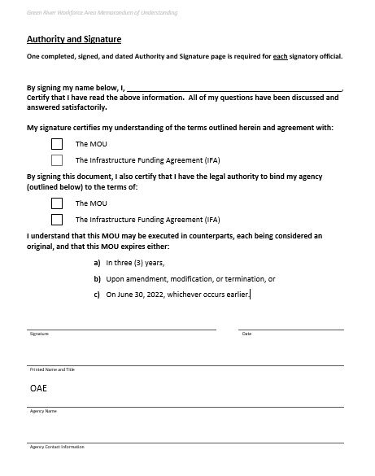

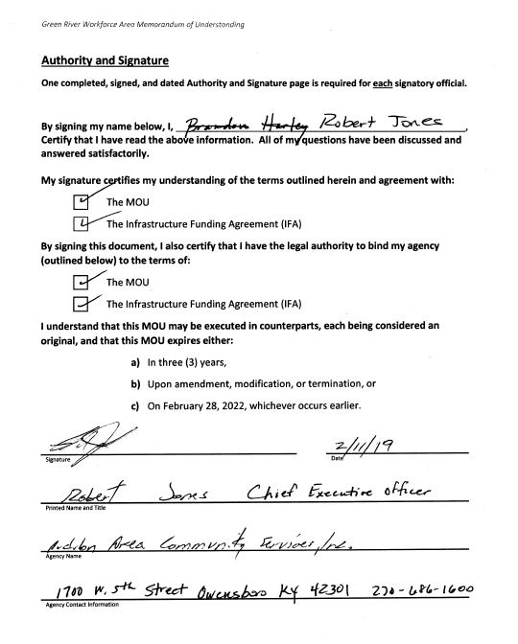

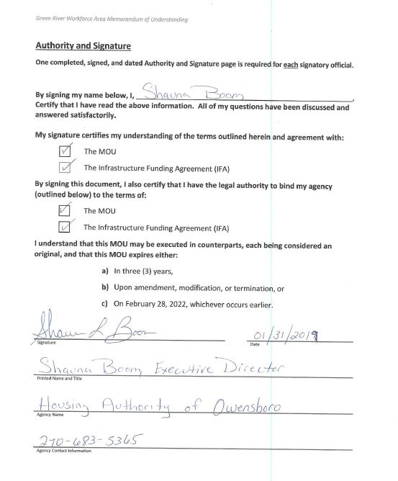

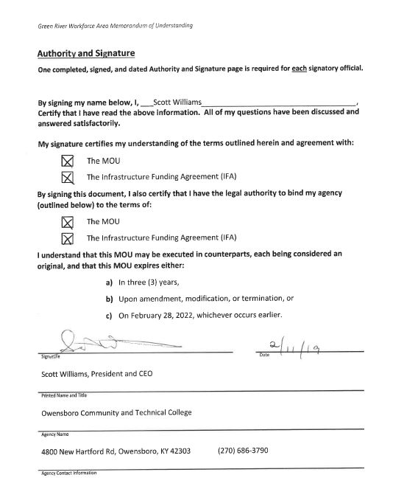

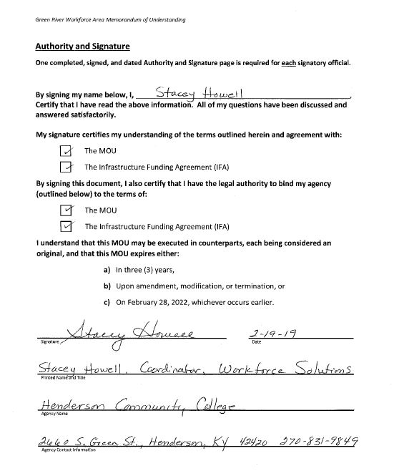

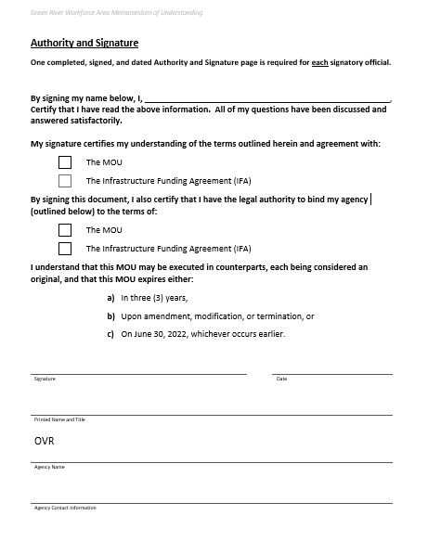

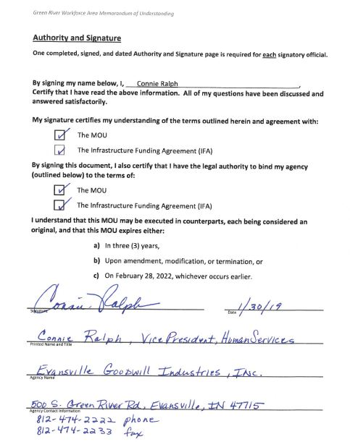

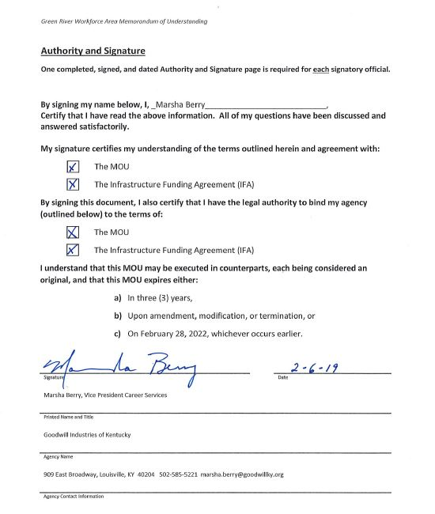

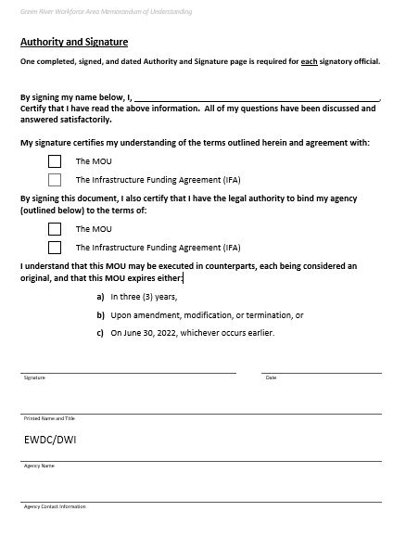

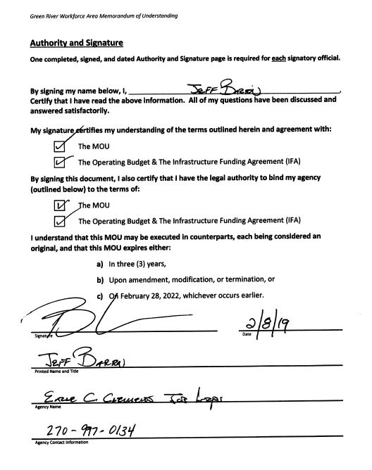

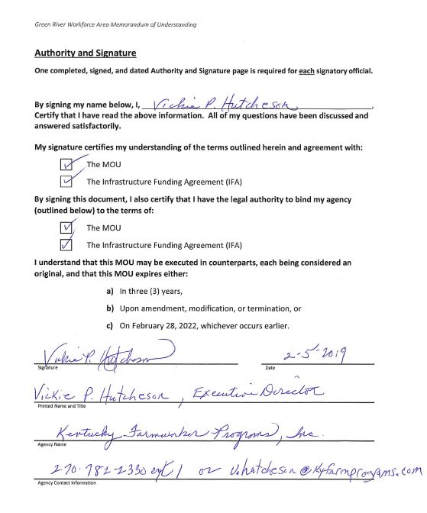

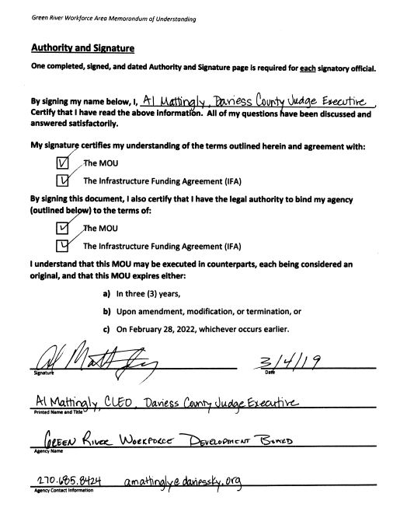

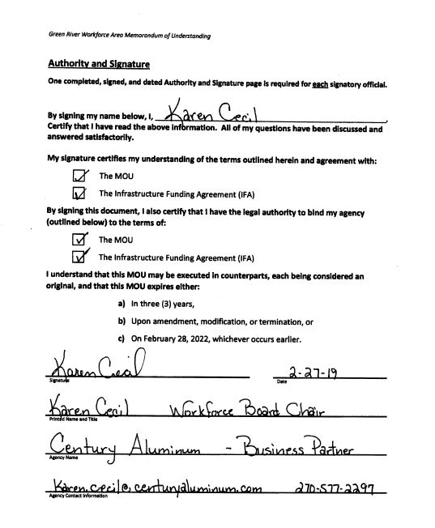

Attachment A – Agencies to the Agreement (Required Partners)

Partner Name | Program | Program Authority
Kentucky Office of Adult Education Skills U | Adult Education | Adult Education and Literacy (WIOA 121(b)(1)(B)(iii)) – Title II
Audubon Area Community Services | Community Services Block Grant | Community Services Block Grant Employment & Training Programs (42 USC 9901 et seq.)
Employment and Training Programs- Department of Housing and Urban Development | Housing Authority of Owensboro | Department of Housing and Urban Development (HUD) – Employment and Training Programs (WIOA 121 (b)(1)(B)(xi))
Audubon Area Community Services | TANF | Temporary Assistance for Needy Families (TANF) part A of title IV of Social Security Act (42 U.S.C. 601 et seq.)
Owensboro Community and Technical College | Post-Secondary Vocational Education | Career & Technical Education Programs - Postsecondary Vocational Education – Carl D. Perkins Vocational and Applied Technology Education Act (20 USC 2301)
Henderson Community College | Post-Secondary Vocational Education | Career & Technical Education Programs - Postsecondary Vocational Education – Carl D. Perkins Vocational and Applied Technology Education Act (20 USC 2301)
Audubon Area Community Services | Senior Community Service Employment Program | Older Americans Act Title V – Senior Community Service Employment Program (SCSEP) (42 USC 3056)
Office of Vocational Rehabilitation | Vocational Rehabilitation | Rehabilitation Act, Title I, Parts A & B – Rehabilitation Services Commission (29 USC 720)
Evansville Goodwill Industries | Senior Community Service Employment Program | Older Americans Act Title V – Senior Community Service Employment Program (SCSEP) (42 USC 3056)
Goodwill Industries of Kentucky | Senior Community Service Employment Program | Older Americans Act Title V – Senior Community Service Employment Program (SCSEP) (42 USC 3056)
Career Development Office and ResCare | Trade | Trade Act Title II, Chapter 2 – Trade Adjustment Assistance (TAA) (19 USC 2271)
Office of Unemployment Insurance | Unemployment Insurance | Unemployment Insurance (UI) – (5 USC 85) (ORC Chapter 4141)
Career Development Office | Wagner-Peyser | WIOA Title III – Wagner-Peyser Act Programs (29 USC 49)
Green River Workforce Development Board (ResCare-contractor) | WIOA Title I - Adult, Dislocated Worker and Youth Programs | WIOA Title I – Adult, Dislocated Worker, and Youth Programs
Career Development Office | Veteran's Workforce Programs | – Veteran’s Workforce Programs – Chapter 41 of title 38, United States Code; WIOA 121(b)(1)(B)(viii)
Earle C. Clements Job Corps Academy | Job Corps | WIOA Title I – Job Corps (29 USC 2881-2900, 29 USC 2901)
Kentucky Farmworker Program | Migrant and Seasonal Farmworker Program | WIOA Title I – Migrant and Seasonal Farm Worker Programs (29 USC 2912, 29 USC 2919)
Audubon Area Community Services | TANF | Temporary Assistance for Needy Families (TANF) part A of title IV of Social Security Act (42 U.S.C. 601 et seq.)
Not in this area | Not in this area | WIOA Title 1 – Youthbuild – WIOA Section 171
Not in this area | Not in this area | Second Chance Act of 2007 programs, authorized under section 212 (42 U.S.C. 17532)
Not in this area | Not in this area | WIOA Title I – Native American Programs (29 USC 2911, 29 USC 2919)

Attachment B - Agency Commitments

Partner Name | Program Name | Services (Enter Number from Attachment C) |  |  | Service Delivery Method
 | (from Attachment A) | Career | Training | Employer | (Attachment C)
Kentucky Office of Adult Education Skills U | Adult Education and Literacy | 1, 2, 3, 4, 7, 8, 12, 13, 17 | 7, 8 |  | T,B
Audubon Area Community Services | Community Services Block Grant | 1,2,3,4,5,6,7,8,10,11,12,13,14,15,16,17 | 1,2,3,4,5,6,7,9 | 1,2,3,4,5,6,7 | T,B
Audubon Area Community Services | - TANF (KY Works Program)  - SCSEP (Henderson, Ohio, Union, Webster) | 1,2,3,4,5,6,7,8,10,11,12,13,14,15,16,17 | 1,2,3,4,5,6,7,9 | 1,2,3,4,5,6,7 | T,B
Employment and Training Programs- Department of Housing and Urban Development | Housing Authority of Owensboro | 2,4 |  |  | T,B
Owensboro Community and Technical College | Post-Secondary Vocational Education | 1,2,3,4,5,6,7,8,10,11,12,13,15,16,17 | 1,3,5,6,7,8,9 | 1,2,3,4,5,6,7,8, | T,B
Henderson Community College | Post-Secondary Vocational Education | 1,2,3,4,5,6,7,8,10,11,12,13,15,16,17 | 1,3,5,6,7,8,9 | 1,2,3,4,5,6,7,8, | T,B
Office of Vocational Rehabilitation | Vocational Rehabilitation | 1, 2, 3, 4, 7, 8, 10, 12, 13, 15, 16, 17 | 1, 2, 3, 4, 5, 6, 7 | 2, 4, 7, 8 | FT, C/OFF, T, B
Evansville Goodwill Industries | Senior Community Service Employment Program | 1, 2, 3, 4, 5, 8, 11, 12, 13, 17 | 2 | 1, 2, 3, 7 | T,B,P
Goodwill Industries of Kentucky | Senior Community Service Employment Program | 1, 2, 3, 4, 5, 8, 11, 12, 13, 17 | 2 | 1,2,3,7 | T,B
Career Development Office, ResCare | Trade | 1,2,3,4,5,6,7,8,9,10,11,12,13,14,15,16,17 | 1,2,4,5,6,7,8 | 1,3,6,7,8 | FT, T,B
Office of Unemployment Insurance | Unemployment Insurance | 1,2,3,4,5,8,9,13,14,15,16 |  | 8 | T,B
Career Development Office | Wagner-Peyser | 2,3,4,5,7,10,12,13,14,15 | 7 | 1,2,3,4,6,7 | FT, T, B
ResCare | WIOA Title I - Adult, Dislocated Worker and Youth Programs | 1,2,3,4,5,6,7,8,10,11,12,13,14,15,16,17 | 1,2,3,4,5,6,7,9 | 1,2,3,4,5,6,7,8 | FT, T, B, P
Career Development Office | Veteran's Workforce Programs | 1,2,3,4,5,8,10,12,13,15,17 | 2,4,7 | 1,2,3,4,6,7 | FT, T, B, P
Earle C. Clements Job Corps Academy | Job Corps | 1,2,3,4,5,7,10,11,12,13,14,15,16,17 | 1,2,3,4,5,6,7 | 1,2,3,4,5,6,7 | FT, P
Kentucky Farmworker Program | Migrant and Seasonal Farmworker Program | 1,2,3,4,8,10,11,12,13,15,16,17 | 1,2 | 1,2,3 | T,B

Required Partner Services: The table above identifies the services each required partner will provide and the method(s) of service delivery each partner will use. The services are identified by the corresponding numbers listed for each service in the KCC Services Document. The service delivery methods are identified by the codes listed in the KCC Services Document.

Attachment C – Kentucky Career Center Services

Career Services: Career services include self-help services, services requiring minimal staff assistance and services requiring more staff involvement, generally provided to individuals unable to find employment through basic career services, and deemed to be in need of more concentrated services to obtain employment; or who are employed but deemed to be in need of more concentrated services to obtain or retain employment that allows for self-sufficiency.

- Eligibility Determination: This is the process of obtaining and documenting information about an individual’s circumstances and comparing that information with the criteria set by an agency or program to decide if the individual qualifies for participation.

- Outreach, Intake, and Orientation: Outreach activities involve the collection, publication, and dissemination of information on program services available and directed toward jobless, economically disadvantaged, and other individuals. Intake is the process of collecting basic information, e.g., name, address, phone number, SSN, and all other required information to determine eligibility or ineligibility for an individual’s program. Orientation, whether offered in a group setting, on-on-one, or electronically, is the process of providing broad information to customers in order to acquaint them with the services, programs, staff, and other resources at the KCC, affiliate, or self-service location.

- Initial Assessment: For individuals new to the workforce system, initial assessment involves the gathering of basic information about skill levels, aptitudes, abilities, barriers, and supportive service needs in order to recommend next steps and determine potential referrals to partners or community resources.

- Job Search, Placement Assistance, and Career Counseling: Job Search helps an individual seek, locate, apply for, and obtain a job. It may include but is not limited to: job finding skills, orientation to the labor market, resume preparation assistance, development of a job search plan, job development, referrals to job openings, placement services, job finding clubs, job search workshops, vocational exploration, relocation assistance, and re-employment services such as orientation, skills determination, and pre-layoff assistance. Placement Assistance is a service that helps people to identify and secure paid employment that matches their aptitude, qualifications, experiences, and interests. Career Counseling is a facilitated exploration of occupational and industrial information that will lead to a first, new, or a better job for the individual.

- Employment Statistics-Labor Market Information: Collect and report data about employment levels, unemployment rates, wages and earnings, employment projections, jobs, training resources, and careers; see Kentucky LMI kylmi.ky.gov.

- Eligible Provider Performance and Program Cost Information: Collect and provide information on:

  - Eligible training services providers (described in WIOA Section 122).
  - Eligible youth activity providers (described in WIOA Section 123).
  - Eligible adult education providers (described in WIOA Title II).
  - Eligible postsecondary vocational educational activities and vocational educational activities available to school dropouts under the Carl Perkins Act (20 USC 2301).
  - Eligible vocational rehabilitation program activities (described in Title I of the Rehabilitation Act of 1973).

- Local Performance Information: Collect and provide information on the local area’s recent performance measure outcomes.

- Supportive Services’ Information: Collect and provide information on services such as transportation, child care, dependent care, housing, and needs-related payments that are necessary to enable an individual to participate in employment and training activities.

- Unemployment Compensation: Collect and provide information on filing claims for state benefits payments that protect individuals from economic insecurity while they look for work. Claims may be filed on-line or via telephone available in the KCC.

- Eligibility Assistance: Provide guidance to individuals on eligibility for other programs and on financial aid assistance for training and education programs that are available in the local area.

- Follow-Up Services: Services provided to participants who are placed in unsubsidized employment, for not less than 12 months after the first day of employment. These services assist those individuals to maintain employment or qualify for promotions with that employment.

- Comprehensive and Specialized Assessments: A closer look at the skill levels and service needs that may include:

  - Diagnostic Testing and use of other assessment tools; and
  - In-depth interviewing and evaluation to identify employment barriers and appropriate employment goals.

- Individual Employment Plan Development: Working with individuals to identify their employment goals, the appropriate achievement objectives, and the appropriate combination of services that will help the individual achieve those goals.

- Group Counseling: Involves two or more participants addressing certain issues, problems, or situations that may be shared by the group members.

- Individualized Counseling and Career Planning: One-on-One counseling or planning session that may go into greater detail for a participant regarding certain issues, problems or situations.

- Case Management: For participants who receive training services under WIOA Section 134 (d)(4).

- Short-Term Prevocational Services: Can include development of learning skills, communication skills, interviewing skills, punctuality, personal maintenance skills, and professional conduct, to prepare individuals for unsubsidized employment or training.

Training Services: Services offered through a training provider to help individuals upgrade their skills, earn degrees and certifications, or otherwise enhance their employability through learning and education. Types of training services include:

- Occupational Skills Training: An organized program of study that provides specific vocational skills that lead to proficiency in performing actual tasks and technical functions required by certain occupational fields at entry, intermediate or advanced levels.

- On-the-Job Training (OJT): Training by an employer that is provided to a paid participant while engaged in productive work that is limited in duration, provides knowledge or skills essential to the full and adequate performance of the job, and reimburses the employer for the costs associated with training the OJT trainee often calculated based on a percentage of the trainee’s wages.

- Workplace and Cooperative Education: Programs that combine workplace training with related instruction which may include cooperative education programs.

- Training Programs Operated by the Private Sector: Training provided by an employer that is formed by a strong relationship among businesses and public education and training programs to coordinate employers’ needs with what training programs provide. Provides opportunities for employers to influence pre-existing programs or design new ones that meet their specific and changing needs.

- Skills Upgrading and Retraining: Courses that prepare persons for entrance into a new occupation through instruction in new and different skills demanded by technological changes. These courses train incumbent workers in specific skills needed by that business or industry and that lead to potential career growth and increased wages. This includes courses that develop professional competencies that are particularly relevant to a vocational/occupational goal. It must be demonstrated that the training will result in the workers’ acquisition of transferable skills or an industry-recognized certification or credential.

- Entrepreneurial Training: In partnership with a provider in the community, training that assists an individual in developing the skills associated with entrepreneurship which may include skills such as developing budgets and forecasting resource needs, understanding various options for acquiring capital and the trade-offs associated with each option, and communicating effectively with the ability to market oneself and one’s ideas.

- Job-Readiness Training: Promotes the development of good work habits and essential skills for individuals who are unable to retain employment due to lack of basic work readiness/employability skills. This allows an individual the opportunity to learn basic essential skills and provide job specific skills that could be transferrable to a future career.

- Adult Education and Literacy (ABLE) Programs: Services or instruction below the postsecondary level for individuals who are not enrolled or required to be enrolled in secondary school under state law and lack basic educational skills to enable the individuals to function effectively in society and on a job. Services include, but are not limited to, one-on-one instruction, coursework, or workshops that provide direction for the development and ability to read, write, and speak in English, compute, and solve problems, at levels of proficiency necessary to function to society or on the job.

- Customized Training: Training that is designed to meet the special requirements of an employer or group of employers and that is conducted with a commitment by the employer to employ an individual upon successful completion of the training and for which the employer pays for a portion of the cost of training.

Employer Services: KCC services offered to employers include:

- Employer Needs Assessment: Evaluation of employer needs, particularly future hiring and talent needs.

- Job Posting: Receiving and filling of job openings; searching resumes; providing access to a diverse labor pool.

- Applicant Pre-Screening: Assessing candidates according to the employer’s requirements and hiring needs; referring candidates based on their knowledge, skills, and abilities relative to the employer requirements.

- Recruitment Assistance: Raising awareness of employers and job openings and attracting individuals to apply for employment at a hiring organization. Specific activities may include posting of employer announcements, providing of job applications, and hosting job fairs and mass recruitments.

- Training Assistance: Provide WIOA work based training resources to enable employers to upgrade employee skills, introduce workers to new technology, or to help employees transition into new positions. Such as On the Job Training (OJT), incumbent worker training, work experience, customized training and registered apprenticeship.

- Labor Market Information: Access to information on labor market trends, statistics, and other data related to the economy, wages, industries, etc.

- Employer Information and Referral: Provision of information on topics of interest to employers such as services available in the community, local training providers, federal laws and requirements, tax information, apprenticeship programs, human resource practices, alien labor certifications, incentive programs such as WOTC or the federal bonding program, etc.

- Rapid Response and Layoff Aversion: Provision of services to prevent downsizing or closure, or to assist during layoff events. Strategies may include incumbent worker training to avert lay-offs, financing options, employee ownership options, placement assistance, worker assessments, establishment of transition centers, labor-management committees, peer counseling, etc.

- Employer Requested Assessments: Test of Adult Basic Education (TABE), Worldwide Interactive Network (WIN) Career Readiness System and the National Career Readiness Certificate (NCRC).

- Accessing Untapped Labor Pool: Connect employers with Veterans, Youth, Individuals Acknowledging they have a Disability and Language Barriers.

Service Delivery Codes:

Code | Method Description
FT | On-Site Staff Full Time
PT | On-Site Staff Part Time
C | Contracted Service On-Site Full Time
C/PT | Contracted Service On-Site Part Time
C/Off | Contracted Service Off-Site
T | Access Via Telephone
A | Access Via Automated System
B | Brochure/Handout
P | Posting at One-Stop Center
O | Other
NA | Not Applicable

Attachment D

Definitions

Administrative Entity:
Entity(ies) designated by the CEO to coordinate and administer WIOA activities and services within a local area on the LWDB’s behalf and in accordance with all applicable federal, state, and local laws, regulations, rules, policies, plans, and the terms of this MOU.

Chief Elected Official:
Identified in WIOA Section 3 Definitions (9) as the chief elected officer of a unit of general local government in a local area or the individual(s) designated under a local agreement pursuant to WIOA Section 107(c)(1)(B).

Career Services:
The services which shall be available, at a minimum, to individuals who are adults or dislocated workers through the KCC delivery system in each local area. The career services that must be provided as part of the KCC delivery system are listed in WIOA Section 134(c)(2), as identified on pages 9-11.

Continuous Improvement:
States will establish criteria to certify one stop centers at least every three years to ensure continuous improvement of the system, including access to services (including virtual access), customer needs being met, and integrated service delivery for job seekers and employers as a part of WIOA'S Three Hallmarks of Excellence:
- The needs of businesses and workers drive workforce solutions and local boards are accountable to communities in which they are located;
- One-Stop Centers (or American Job Centers) provide excellent customer service to jobseekers and employers and focus on continuous improvement; and
- The workforce system supports strong regional economies and plays an active role in community and workforce development.

Cost Allocation:
Per 66 Fed. Reg. 29639, cost allocation is the measurement of actual costs in relation to the benefit received in order to determine each partner’s fair share of KCC operating costs.

Cross-Training:
Gaining knowledge of other entities programs and offerings, by all KCC staff, ensuring quality services and referrals, regardless of any partner staff/employee availability.

Fair Share:
The portion of KCC operating costs allocated to each partner in proportion to the use of and benefits the partner receives from participation in the KCC system.

Fiscal Agent:
An entity appointed by a local area’s CEO in accordance with WIOA Section 107 (d)(12)(B)(i)(II) & (III)) to be responsible for the administration and disbursement of WIOA and other funds allocated for workforce development activities in the local area. WIOA Section 107(d)(12)(B)(i)(II) provides that designation of a fiscal agent does not relieve the CEO from his/her liability for any misuse of grant funds

Office of the Kentucky Workforce Innovation Board (OKWIB):
Established by the Kentucky Governor to assist the Governor in creating an integrated statewide strategic plan for workforce development which will link workforce policies, education and training programs, and funding streams with the economic needs of Kentucky and its regions and in complying with the provisions and requirements of WIOA Section 101.

Leverage/ Leveraged Resources:
Leveraged Resources are all resources used by partners and communities to support Workforce activities and desired WIOA outcomes, whether or not those resources meet the standards of allowable matches, to support the system and show support of activities.

Examples of Types of Leveraged Activities include, but are not limited to: Training; Tuition Grants; Other Job Readiness Activities and Services; Grants or matching funds for certification fees; Grants of tools or other required, job-specific supplies; Construction or purchase of facilities for housing of grant activities; Donated supplies, personnel services, equipment, or space; cash; in kind contribution

Local Area:
A local workforce development area designated by the Governor, under WIOA section 106, subject to sections 106(c)(3)(A), 107(c)(4)(B)(i), and 189(i)

Local Workforce Development Board (LWDB):
The board created pursuant to WIOA Section 107 with responsibility for the development of the local plan and for oversight of the workforce development activities in the local area.

Memorandum of Understanding (MOU) Agreement Period:
The MOU must not be for a period to exceed three years. Additionally, per WIOA 121(c)(2)(v), the duration of the MOU and the procedures for amending the MOU during the duration of the MOU, and assurances that such memorandum shall be reviewed not less than once every 3-year period to ensure appropriate funding and delivery of services.

Kentucky Career Center (KCC):
The Kentucky Career Center (KCC) is the state logo for the Kentucky One stop delivery system and used with the federal American Job Center Network logo. The KCC is essentially a collaborative effort among public service agencies, non-profit organizations and private entities that administer workforce investment, educational, and human resource programs to make the variety of services available under those programs more accessible to eligible job seekers and employers in the local area. [TEGL 16-16]

Kentucky Career Center One-Stop Operator:
An entity or consortium of entities designated in accordance with WIOA Section 121(d) to operate a KCC site and to perform KCC service delivery activities in accordance with all applicable federal, state, and local laws, regulations, rules, policies, guidance, plans, and the terms of this MOU.

Resource Sharing:
Per 66 Fed. Reg. 29639, Resource Sharing is the cash and/or resources each partner will contribute to fund its fair share of costs for operation and infrastructure funding of the KCC system. This can include “in-kind” contributions from third parties to partner programs. The LWDB, CEO and KCC partners may fund the costs of infrastructure off KCCs through methods agreed on by the LWDB, CEO and KCC partners through negotiation of the IFA/Resource Sharing. [TEGL 16-16 & TEGL 17-16]

Training Services:
Services to adults and dislocated workers as described in WIOA Section 134(c)(3). Per WIOA 134(c)(3)(D) these may include occupational skills training, including training for nontraditional employment, on-the-job training, incumbent worker training, programs that combine workplace training with related instructions, which may include cooperative education programs, private-sector training programs, skill upgrading and retraining, apprenticeships, entrepreneurial training, transitional jobs, job-readiness training, adult education and literacy activities in combination with a training program, or customized training.

WIOA
The Workforce Innovation and Opportunity (WIOA) Act, PL 113-128, amends the Workforce Investment Act of 1998 to strengthen the United States workforce development system through innovation in, and alignment and improvement of, employment, training, and education programs in the United States, and to promote individual and national economic growth, and for other purposes.

WIOA Local Plan
Per WIOA Section 108, the local plan is a comprehensive 4-year plan developed by each LWDB, in partnership with the chief elected official and submitted to the Governor. The plan shall support the strategy described in the State plan. At the end of the first 2-year period of the 4-year local plan, each local board shall review the local plan, and the local board, in partnership with the chief elected official, shall prepare and submit modifications to the local plan to reflect changes in labor market and economic conditions or in other factors affecting the implementation of the local plan. Plans identify the respective local area’s current and projected workforce investment needs, the KCC delivery system, performance standards, and strategies to address the workforce investment needs in consideration of performance standards per WIOA Section 116.

WIOA State Plan
The term “State plan”, used without further description, means a unified State plan under section 102 or a combined State plan under section 103.

