Resources and information shared during the April 22, 2020, SIAC meeting:
- Link for System of Care Academy updates: http://www.systemofcareacademy.eku.edu/
- www.kycovid19.ky.gov
- If anyone needs information on Video Remote Interpreters for American Sign Language, please email Michelle.Niehaus@ky.gov. Several agencies are offering the service with telehealth.
- Link to register for Parent Cafes: http://events.constantcontact.com/register/event?llr=xmzewwvab&oeidk=a07eh1d79y1df3f51dd
- Kentucky Hands & Voices is also offering weekly virtual Parent Cafes for families with children who are Deaf, Hard of Hearing, or Deaf-Blind. They are at 2:00 and 7:00 each Tuesday. For more info, go to the KY Hands & Voices Facebook page.
- Resources from Kentucky Department of Education that address social/emotional well-being during this time: https://education.ky.gov/curriculum/Pages/Comprehensive-School-Counseling.aspx
- KY-SPIN’s website that has a compiled list of resources and webinars they are currently offering: https://www.kyspin.com/
- Regional Prevention Center (RPC) Staff trained to teach Too Good (TGFD) across the state are currently in the process of recording the lessons for each grade K-HS. These will be posted online, along with a short pre/posttest very soon. These will be available to all youth across the Commonwealth. If you would be interested in getting the link to these tools, please let Laura Edwards know, and she can send the link when they are ready: Laura.Edwards@ky.gov
- Virtual Youth Fest will be every Thursday. It is a national event. Please share with teens and young adults. http://www.bit.ly/mylifeyouthfest?fbclid=IwAR2AIC8pvY7DqealOzqfkHt-Q2NWn1XZ9GIyjnwiBtc-UACokstwpDphiRA
- Resources from the Kentucky Autism Training Center: new website for COVID-19 specific resources https://bit.ly/ASDathome
- UofL colleagues at the Early Learning Campus created some videos for caregivers of young children (preschool and younger): https://www.youtube.com/playlist?list=PLo-wvwE3LO33WHHoiLukUIL_lB3pYUJon&fbclid=IwAR13TVpkSnCaUeM_IM_OXjzT3u7f0QY9swegqU9I05YYxY_aA6cingaoXXw&app=desktop
- SAMHSA's MHTTC - COVID response page has guidance for education systems, including remote options for staff wellness, crisis planning, telehealth, SEL at home, support for parents, assisting with grief, teacher strategies https://mhttcnetwork.org/centers/global-mhttc/responding-covid-19-school-mental-health-resources
- Video on how to increase security to prevent Zoom bombing: https://www.youtube.com/watch?v=MRO0DFYzwkg https://www.youtube.com/watch?v=60kGONUJSRY
- Video from NIMH called Five Things About Staying Mentally Healthy During the COVID-19 Outbreak https://www.youtube.com/watch?v=60kGONUJSRY
- Kentucky Partnership for Families and Children has provided cell phones and hotspots for some transition age youth across the state to support telehealth. The cost is a little over $5000. If anyone wants to support a transition age youth's telehealth equipment, it costs approximately $225 per TAY. We will share a flier in the next few days. For more information about KPFC, visit https://kypartnership.org/ or email Carol Cecil at cwcecil@kypartnership.org

- Department for Medicaid Services: COVID information page which includes FAQs that are constantly updated: https://chfs.ky.gov/agencies/dms/Pages/cv.aspx
Chart showing Medicaid Enrollment numbers from December 2019 to present:
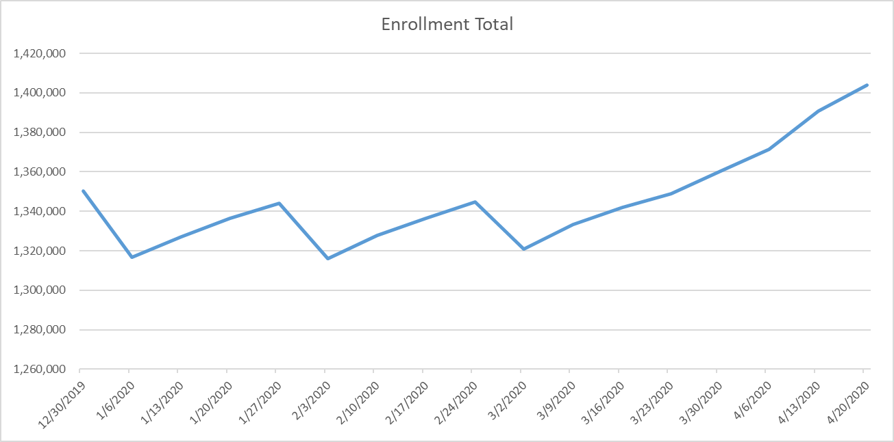
- Medicaid Recipients Get Expanded Phone Use, Telehealth Services: https://www.wtvq.com/2020/04/08/medicaid-recipients-get-expanded-phone-use-telehealth-services/?fbclid=IwAR0ZjnRloLSqUsaaRUV5gBW_smxyxhJe8FpAJY8wTeGtyg4If8u8KAm1VN8
- Report Child Abuse/Neglect
To report child abuse and neglect call toll-free any of the numbers listed below:
(877) 597-2331/(877) KYSAFE1
(800) 752-6200
Report Online https://prdweb.chfs.ky.gov/ReportAbuse/ - non-emergency only
Monitored from 8 a.m. to 4:30 p.m. Eastern time, Monday through Friday (Reports will not be reviewed during evenings, weekends or state holidays)
Call 911 in case of an emergency
- DCBS COVID-19 Resources and Information: https://chfs.ky.gov/agencies/dcbs/Pages/dcbscvres.aspx

