**Guide Techniques**

**Jennifer Roark Dumas M.Ed., COMS**

Office of Vocational Rehabilitation Blind Services

859-226-5169, [Jennifer.Dumas@ky.gov](mailto:Jennifer.Dumas@ky.gov)

Human guide enables the blind or visually impaired to get around safely in unfamiliar areas, crowds or in dangerous situations. The goal is fortheguide and the follower to feel comfortable and safe while doing this technique. **Always ask if they need assistance. Never grab, push or pull a person with visual impairment. Never leave them in the middle of nowhere.** (In this handout, the follower is the person with visual impairment)

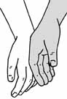

**Stance**

First, the guide asks if the follower needs assistance. If so, they should touch the follower’s arm with the back of their hand

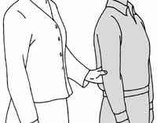The follower moves their hand to just above the guide’s elbow with the thumb on the outside and fingers inside the arm. The follower should be a step behind and slightly to the side of the guide’s shoulder.If balance is an issue, the follower can link arms and hold the guide’s bicep. (Like the follower are going to the prom).

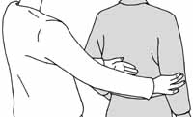

**Changing Sides**

The guide will tell the follower to change sides to use a handrail, door, or reduce fatigue. The follower uses their free hand to slide across the shoulders and down to the elbow.

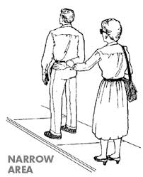 **Narrow Passage**

When the area is too narrow for both persons to fit, the guide moves their arm behind them, and the follower slides their hand down to their wrist and steps in behind. The follower should be careful to extend their arm enough to not step on the guide’s heels.

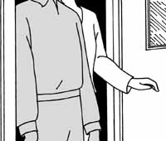 **Doors**

The guide will tell the follower if the door is push, pull and whether the hinges are on the left or right. The guide will open the door and the follower steps behind the guide and catches the door with their free hand. The follower may need to change sides beforehand to be on the hinge side and avoid running into the doorframe.

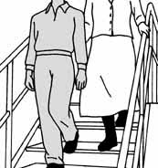 **Stairs and Curbs**

The guide will tell the follower of upcoming steps or curbs and the direction. The guide stops and allows the follower to move beside them while still holding onto their arm. This also allows the follower to use the handrail. The guide then takes a step with the follower one-step behind pausing at the end so the follower can finish.

**Seating**

The guide should tell the follower where the seat it located (in front, beside, etc.) They might place the follower’s hand on the back of the chair so they can locate the seat. They should approach chairs from straight ahead or beside and never at an angle. If it is auditorium seating, enter the row side by side until the follower gets to the desired seat. It is more practical to arrive early enough to sit on the end to avoid stepping over purses and bags.

**Vehicles**

The guide places the follower’s hand on the handle and if able allows them to open the door. Next, place the follower’s hand on top of the door so that they can seat themselves and close the door.

**Self-Protection**

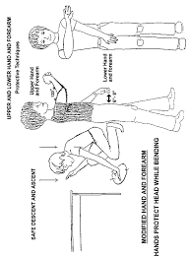Upper forearm technique protects the head and chest from obstacles such as tree limbs and open doors. The arm outstretched across the body at shoulder height with the palm out provides warning to obstacles.

When reaching into cabinet or under the table, one hand placed on the cabinet door or table while the retrieval of items with the opposite hand protects the head as well.

Lower forearm technique protects the waist from obstacles. The extended arm out at approximately 8” with the palm pointing down. Some individuals prefer to hold a rolled-up newspaper for added reach. (All pictures are from https:/Google.com)

**General Etiquette**

The following reminders are good to share with friends and family.

* Introduce yourself and announce your departure during a conversation.
* Use person first language i.e., a person who is blind rather than a blind person.
* Speak normally, look them in eye, and ask if you have questions.
* Use concrete directional terms, i.e., down the hall second door on the left or the snack machine is at 11:00. Avoid vague terms like “it’s over there.”
* Never touch someone’s white cane or give attention to their guide dog without permission.

**Orienting to a New Room**

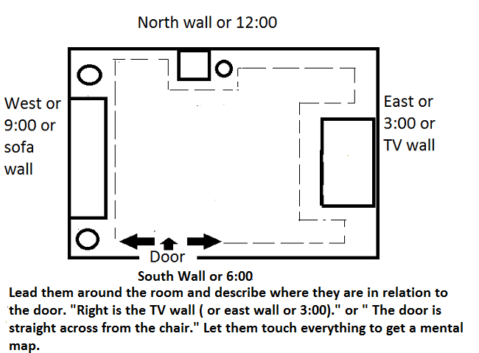Occasionally, it is necessary for a sighted person to orient the person with visual impairment to a new room (i.e., hotel room). Begin at the door and lead them around the room staying close to the walls.