Arthur Campbell, Jr. Advocacy Award

Presented by the Kentucky Statewide Council for Vocational Rehabilitation (SCVR)
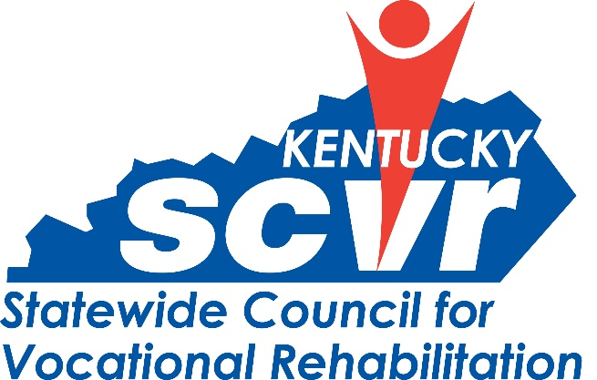
The Statewide Council for Vocational Rehabilitation (SCVR) is a consumer-controlled Council that advises the Kentucky Office of Vocational Rehabilitation. The Arthur Campbell, Jr. Advocacy Award is given annually by SCVR to a person, who has passionately advocated for the rights and equitable treatment of individuals with disabilities, made a significant difference in the quality of life for all individuals with disabilities and has championed independent living, full inclusion and employment for all. Individual(s) who exemplify the traits of leadership, advocacy and dedication to assisting persons with disabilities are eligible for this award.

Nomination Form Instructions
Nominations should explain how the nominee demonstrates excellence in one or more ways. Nominations should be detailed and specific, providing examples of merit wherever possible.
Completed nomination forms are due by the close of business on [Date]. Please send nominations via email to Brooke McDaniel at Brooke.McDaniel@ky.gov.
Statewide Council for Vocational Rehabilitation
500 Mero Street, 1SE
Frankfort, KY 40601 (502)782-3018

Nomination Form

Date: (todays date)

Nominee: (nominees name)

Nominee Contact Information: (nominees)

Nominated by: (your name)

Nominator Contact Information: (your contact info)

The nominee has demonstrated excellence in advocating and assisting persons with disabilities in the following ways:
(Examples: advocate for rights and equitable treatment, made a difference in the quality of life for all and has championed independent living, full inclusion and employment for individuals with disabilities.)

